Chapter-1
INTRODUCTION
A touch sensor is an electronic sensor used in detecting and recording physical touch. Also known as tactile sensors, it’s a small, simple, low-cost sensor made to replace old mechanical switches we seen in the past. They can be found in lamps, touch screens of smartphones, and other wide arrays of applications as well. works like a switch, where when there’s contact, touch, or pressure on the surface of a touch sensor, it opens up an electrical circuit and allows currents to flow through it.
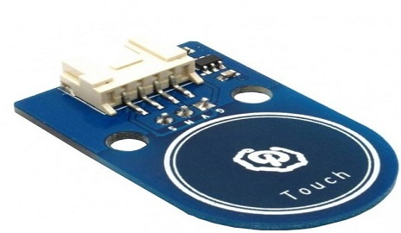
FIG 1.1: Touch sensor
Chapter-2
TYPES OF COMPONENTS
There are three types of ultrasonic sensor
- Wire resistive Sensor
- Surface capacitive Sensor
- Projected capacitive Sensor
- Surface Acoustic Wave Sensor
- Infrared Sensor

- Wire resistive Sensor : In this type of sensor, when user touches screen, two metallic layers make contact. This results into flow of current. The point of contact is determined based on change in the voltage. This type of touch sensors are more affordable but they are damaged with the use of sharp objects.

Application: Thermistors, photoresistors, and potentiometers.
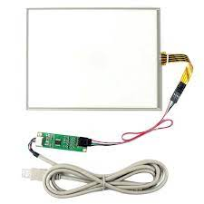
Fig 2.1: wire rsistive sensor
- Surface capacitive Sensor: This sensors are activated with the touch of human skin or a stylus holding an electrical charge. In this type of monitor, a transparent electrode film is placed on top of the glass panel. When exposed finger touches the monitor screen, it reacts to the static electrical capacity of the human body. Some of the charge will get transfer from the screen to the user.
Application: detect position or displacement, proximity, fluid level, humidity and acceleration.
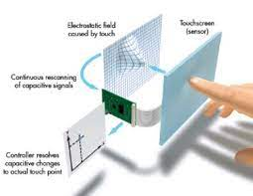
Fig 2.2:surface capacitive sensor
- Projected capacitive Sensor: This type of touch sensor is similar to surface capacitive type. It offers two merits compare to surface capacitive. It can also be activated with the application of surgical gloves as well as thin cotton gloves. It also detects multiple touch points.
Applications: Smartphones and Tablets.
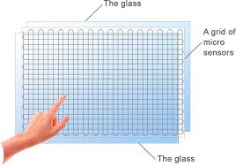
Fig 2.3:projected capacitive sensor
- Surface Acoustic Wave Sensor: SAW touchscreen monitors utilize a series of piezoelectric transducers and receivers. This creates grid of ultrasonic waves on the surface. The other element is placed on the glass referred as reflector. When a panel is touched, portion of the wave is absorbed. This will help receiving transducer to locate the touch point and send this data to the system.
Applications: environmental and health monitoring, chemical and biochemical detection, and signal processing devices.
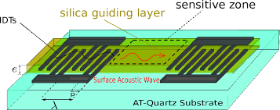
Fig2.3:surface acoustic wave sensor
- Infrared Sensor: This type of touch screen sensor is based on interruption of light path in an invisible light grid in front of the screen. If an obstable appears inside the grid matrix. it will interrupt the light beams and will cause reduction in measured photo current in the detectors. Based on these informations, X-Y co-ordinates can be determined.
Application: gas warning devices, Anesthesiology testing.
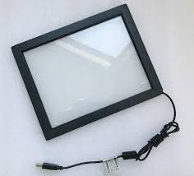
Fig2.3:infrared sensor

Chapter-3
WORKING PRINCIPLE
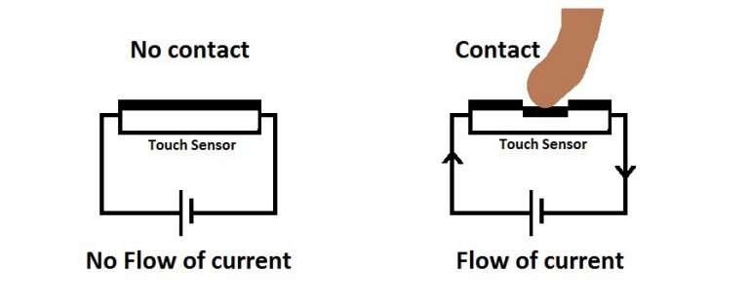
Fig 3.1: Working of touch sensor
Touch sensors work similar to a switch. When they are subjected to touch, pressure or force they get activated and acts as a closed switch. When the pressure or contact is removed they act as an open switch.
Capacitive touch sensor contains two parallel conductors with an insulator between them. These conductors plates act as a capacitor with a capacitance value C0
Touch sensors work similar to a switch. When they are subjected to touch, pressure or force they get activated and acts as a closed switch. When the pressure or contact is removed they act as an open switch.
Capacitive touch sensor contains two parallel conductors with an insulator between them. These conductors plates act as a capacitor with a capacitance value C0
When these conductor plates come in contact with our fingers, our finger acts as a conductive object. Due to this, there will be an uncertain increase in the capacitance.
A capacitance measuring circuit continuously measures the capacitance C0 of the sensor. When this circuit detects a change in capacitance it generates a signal.
The resistive touch sensors calculate the pressure applied on the surface to sense the touch. These sensors contain two conductive films coated with indium tin oxide, which is a good conductor of electricity, separated by a very small distance.

Module Photo
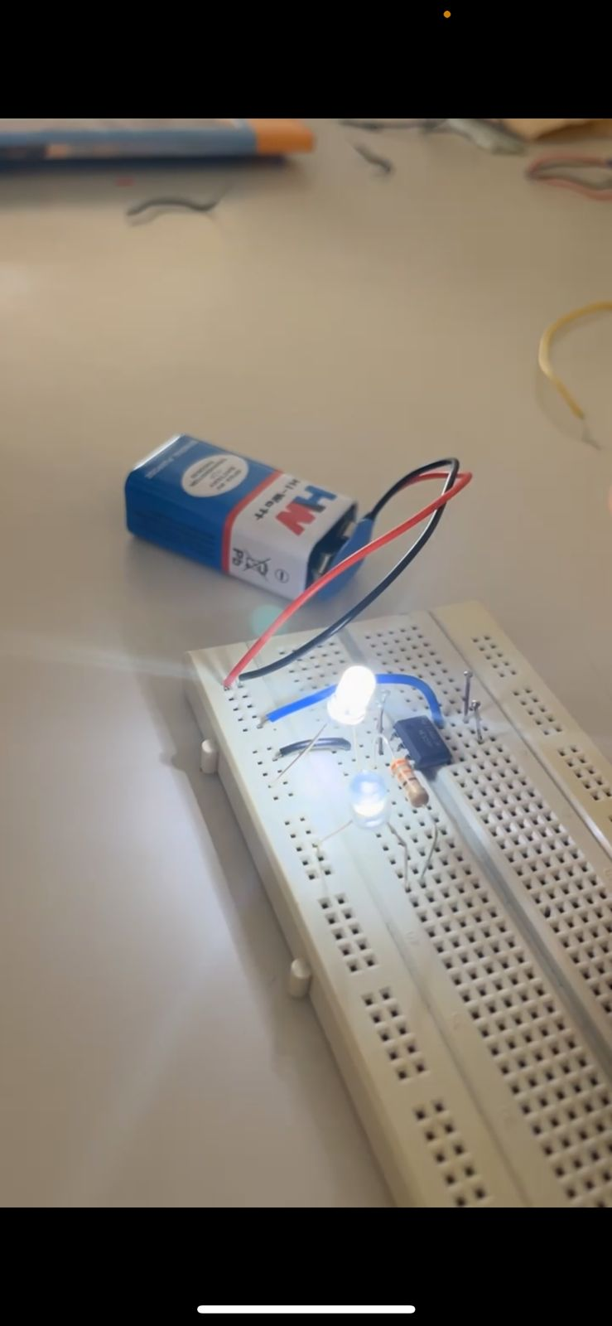

Chapter-4
APPLICATIONS
As mentioned in my introduction, a touch sensor is used for a wide array of applications, with those being:
- Touch sensor in robotics; a touch sensor is commonly used in robots, enabling basic movement and the ability to detect touch in its surroundings (E.g. When the robot runs into something, the touch sensor can have it to stop moving)
- Smartphones, automotive, industrial applications
- Touch sensor faucet in kitchens; allowing for control of running water without having to physically turn the knob
- Most other applications that require pressure/distance measurement
- Portable devices such as smartphones and tablets (iPhones, iPad, etc.)
- Home applications such as touch lamps
- Automotives
- Industrial

Chapter-5
ADVANTAGES AND DISADVANTAGES
Advantages of Touch sensor
- Doesn’t require pressure to be applied since.
- It’s built on the glass itself, hence making force insignificant to sensing requirements.
- Support for multi-touch.
- High responsiveness.

Disadvantages of Touch sensor
- Vulnerable to abrasion.
- Reliability concerns when used in harsh environments.
- Doesn’t work with gloves or a stylus

Chapter-6
CONCLUSION
In conclusion, touch sensors play a crucial role in the world of interactive technology. They have redefined our interaction with electronic devices, making them more intuitive and user-friendly. With continuous advancements in this field, we can anticipate a future where touch sensors become an even more integral part of our daily lives, extending their reach into new and innovative applications. As technology evolves, so too will the capabilities and potential uses of touch sensors, pointing towards an exciting future for this transformative technology.

REFERENCES
[1] https://www.electricity-magnetism.org/touch-sensors/
[2] https://www.seeedstudio.com/blog/2019/12/31/what-is-touch-sensor-and-how-to-use-it-with-arduino/
[3] https://www.elprocus.com/touch-sensor-working-and-its-appplications/

